Communication preferences

Template

Step 1:

1. In the first column, from the list of behaviors below, please choose the top 7 that most resonate with you, by marking a tick ü next to it.
2. On the second column, from the 7 behaviors that you have ticked, now select your top 5 and rank them from most like you (1) to least like you (5).

|  |  |  |
| --- | --- | --- |
| Behavior | My top 7 **ü** | Rank your top 5  *(1 = most like you; 5 = least like you)* |
| Likes challenges | ✔ | 3 |
| Results focused | ✔ | 2 |
| Competitive |  |  |
| Determined | ✔ | 1 |
| Assertive |  |  |
| Decisive |  |  |
| Risk Taker |  |  |
| Sensitive to others |  |  |
| Sociable | ✔ | 7 |
| Emotional |  |  |
| Stimulating |  |  |
| Outgoing |  |  |
| Optimistic |  |  |
| Enthusiastic |  |  |
| Tactful |  |  |
| Calm |  |  |
| Patient |  |  |
| Dependable |  |  |
| Supportive | ✔ | 6 |
| Accommodating |  |  |
| Procedure orientated | ✔ | 5 |
| Precise |  |  |
| Private |  |  |
| Systematic | ✔ | 4 |
| Restrained |  |  |
| Likes numbers |  |  |
| Perfectionist |  |  |
| Critical of mistakes |  |  |

Step 2:

Now please complete your research. Here is a reminder of DiSC. The example behaviors are drawn from the previous table.

Introducing the DiSC model

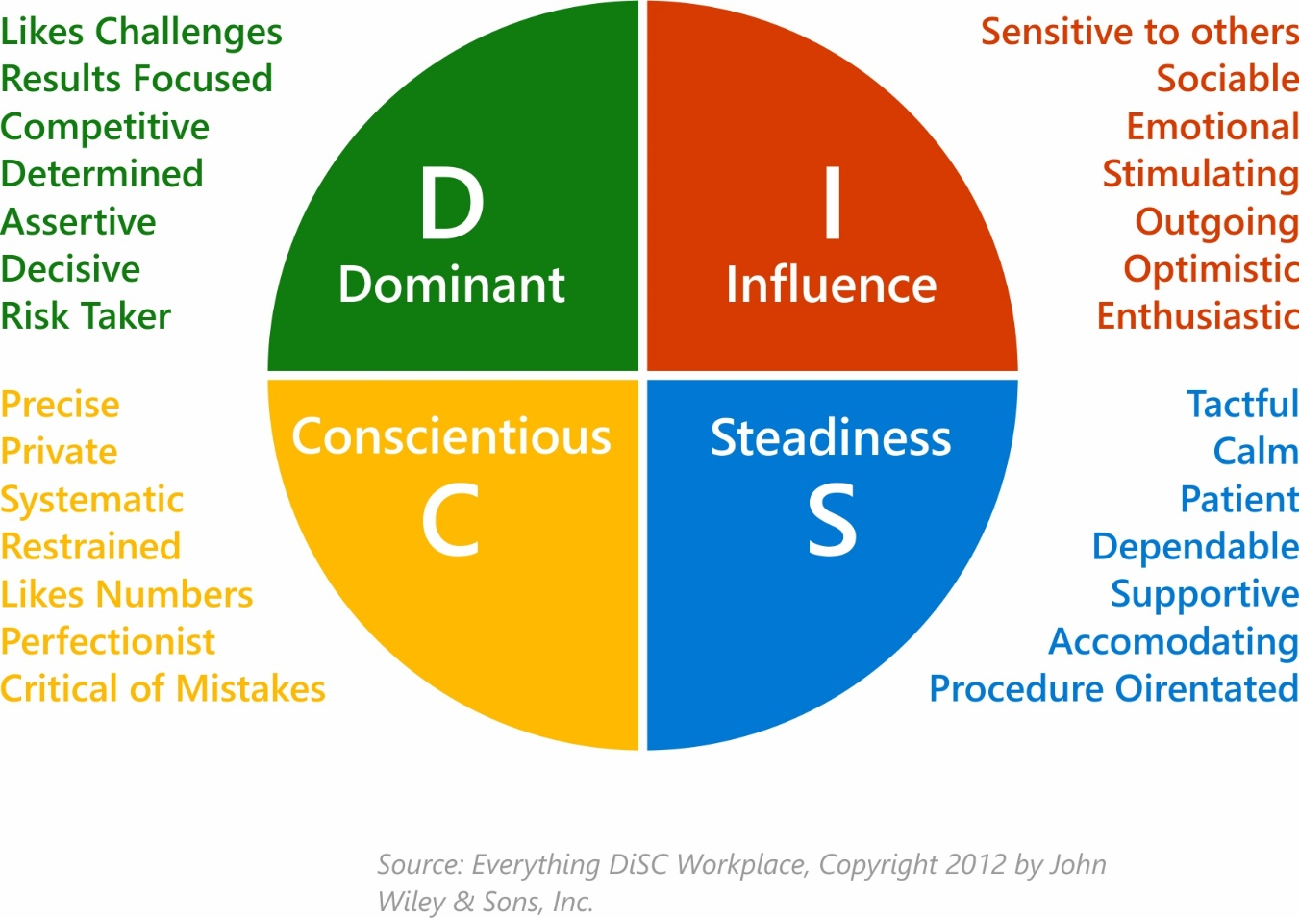

Step 3:

Following your research, answer the final 2 questions below.

1. What have you learned about yourself from the DiSC model?

Answer: I believe that as I’ve aged I’ve become more comfortable being who I am, and in asserting my priorities. I’ve become more myself. I’ve also become much more comfortable moving into another style. So while I don’t typically seek out collaboration, for example, I am not ill at ease working that way. I’ve accepted that I’m introverted and that it’s not a character defect, as another example. So when I see phrases on the DiSC questionnaire that might have seemed a little undesirable to me in the past, I accept them now because I know that my preference does not equal my ability. I can show enthusiasm and be supportive even if I don’t show a strong preference for those behaviors.

1. What have you learned about DiSC and its value when communicating with others?

Answer: I might go straight for facts and logic in an argument and be uncomfortable around strong emotions. I have learned to give myself and others a bit of a break. I understand better how important sharing feelings can be to those on the other side of the DiSC circle. I know that I can experience their reactions to conflict and even share a few feelings of my own. In fact, the i and S styles will be much more willing to listen to my arguments if I give them some of what they need first.

I am more patient with myself, too. I schedule time for myself regularly, even during social gatherings. I need that little bit of distance to recharge and I don’t feel so weird about it. I can better explain to others that I’ll be back to join in again and I’m not angry or withdrawing because I’m hurt. I can ask others to be patient with my needs.